Lab Exercise 12– Terraform IAM User Setting
Prerequisites: Terraform Installed: Make sure you have Terraform installed on your machine. Follow the official installation guide if needed.
AWS Credentials: Ensure you have AWS credentials (Access Key ID and Secret Access Key) configured. You can set them up using the AWS CLI or by setting environment variables.
Exercise Steps:
Step 1: Create a New Directory:
Create a new directory for your Terraform configuration:
“Terraform-Demo”
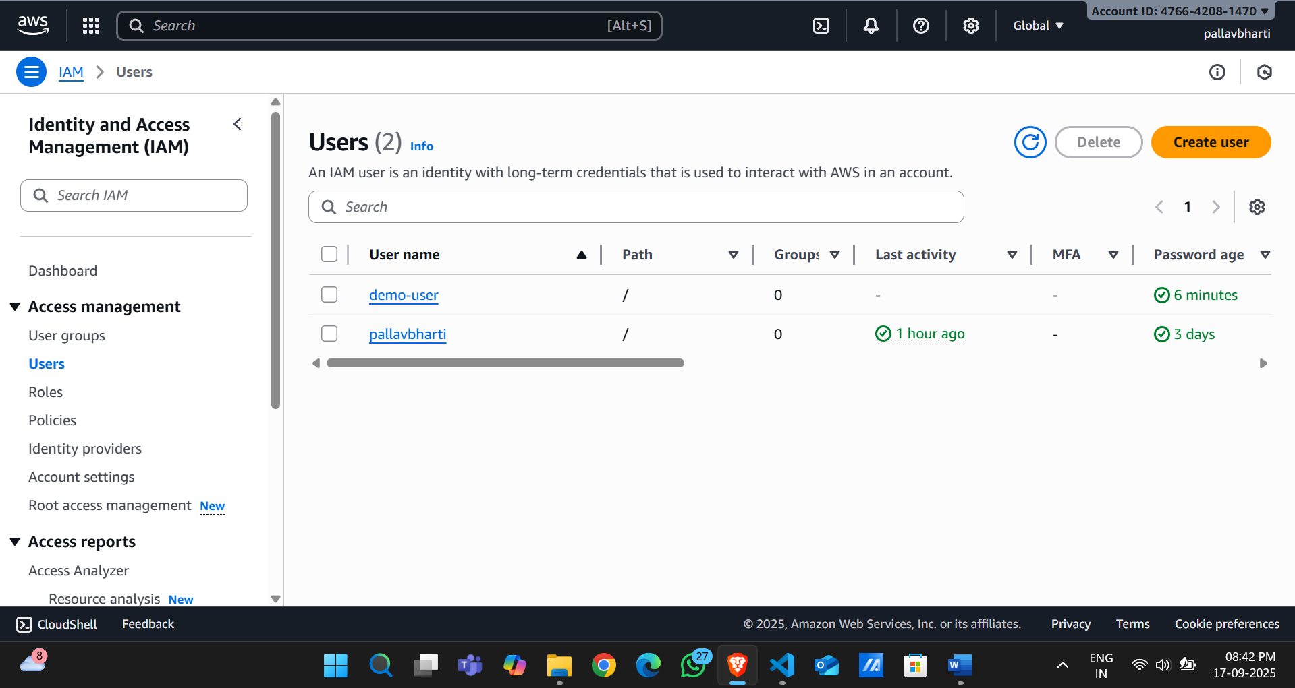

Step 2: Create Terraform Configuration File (main.tf):
Create a file named main.tf with the following content:
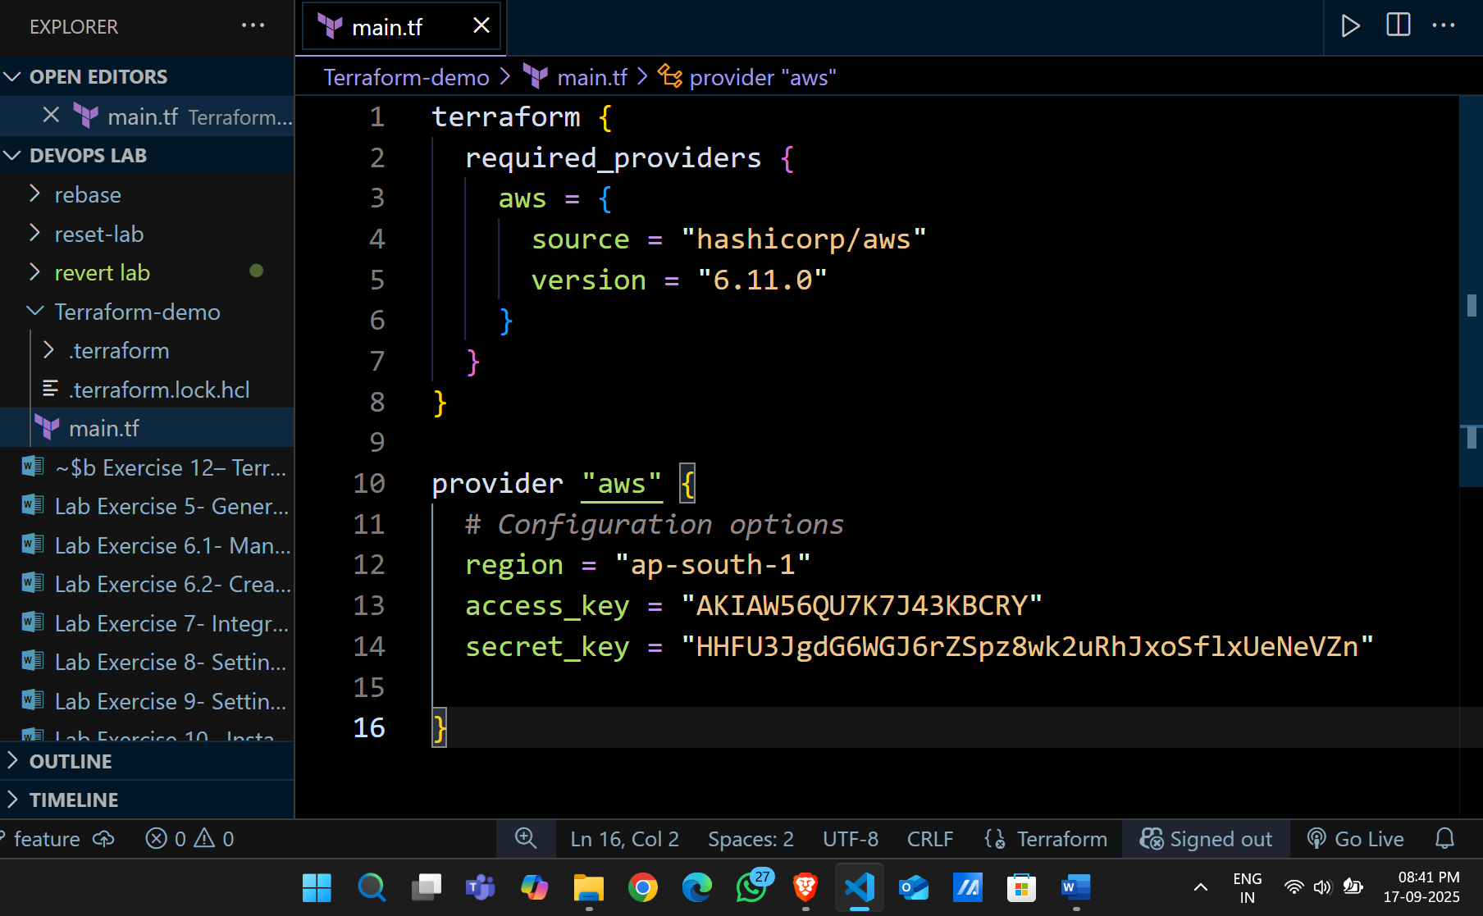
This script defines an AWS provider and provisions an EC2 instance.
Step 3: Initialize Terraform:
Run the following command to initialize your Terraform working directory:
